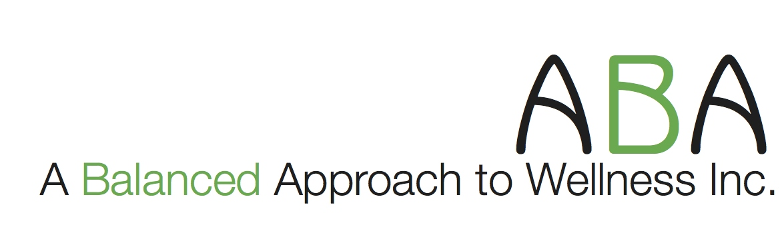  Serving the Bloomington / Normal and surrounding areas  www.abalancedapproach-wellness.com  ABAWellness.inc@gmail.com  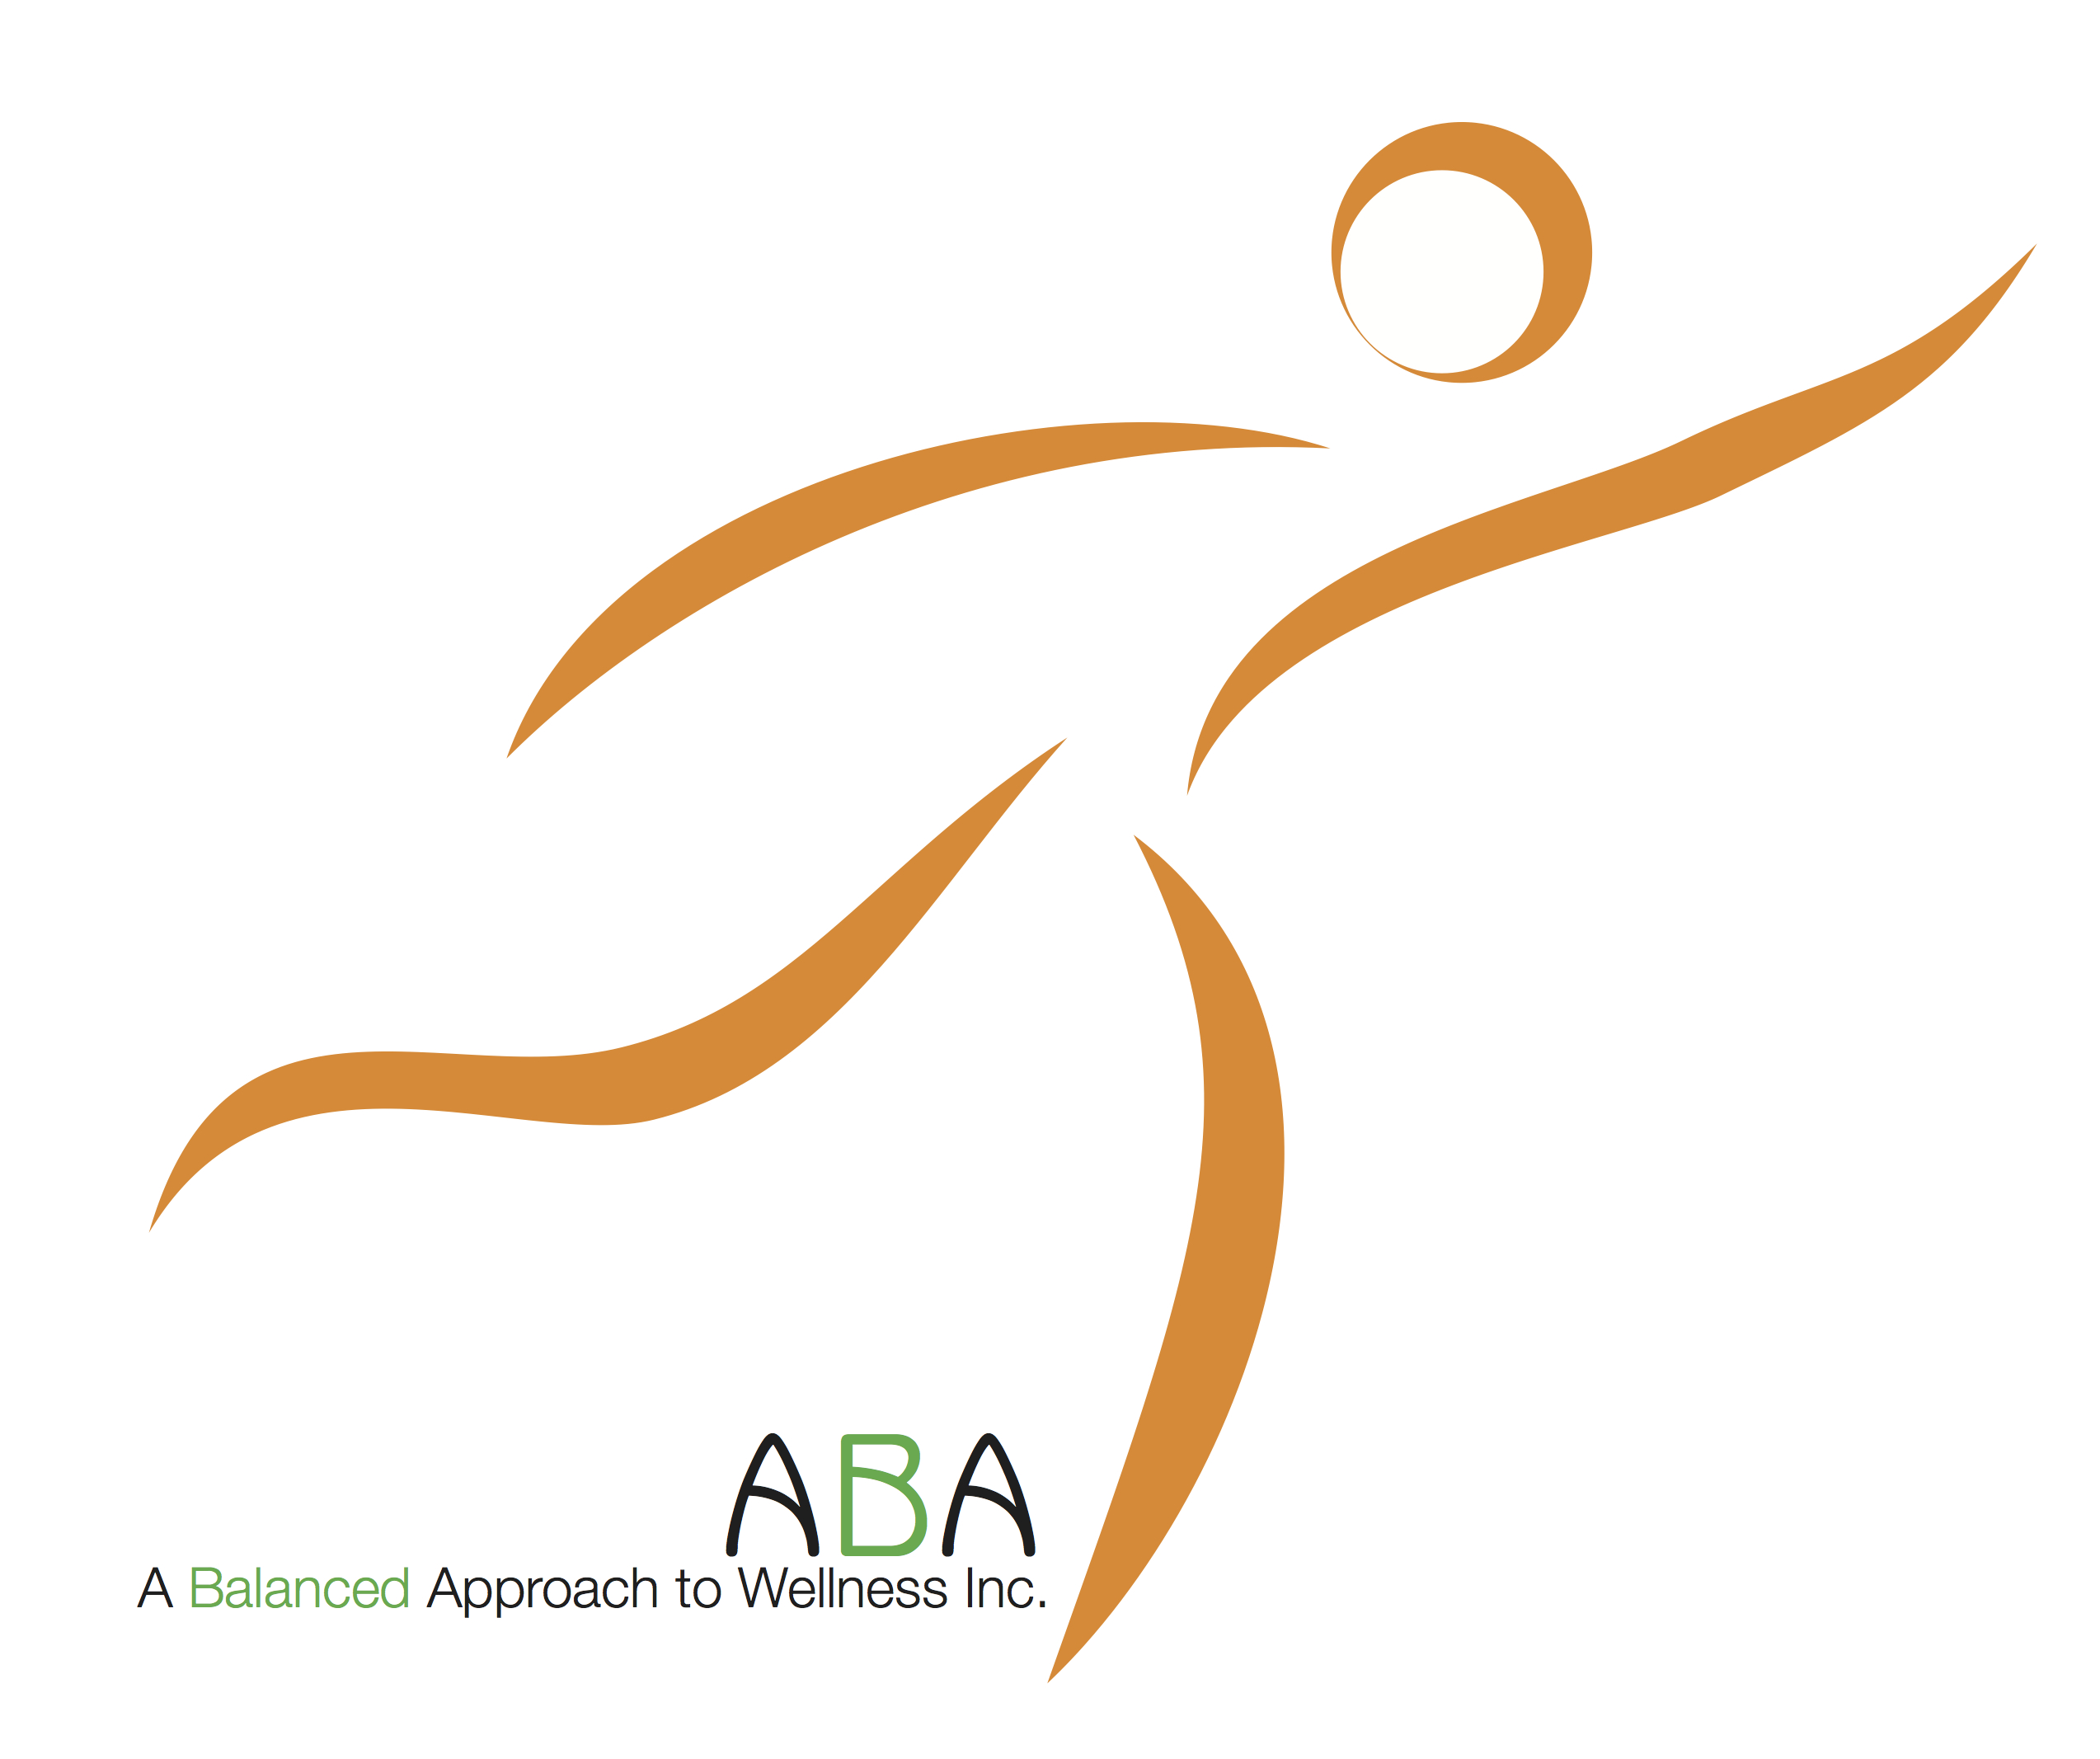 | ABA Wellness, Inc.  President: Savannah Swanlund  P: 309-310-2619  11 Currrency Drive  Bloomington Il 61704

HIPAA Privacy Rights Request Form

Client INFORMATION
 | Date
Name (Last, first, middle initial) | Social Security # or Client ID
Street address, City, ST, ZIP Code
Primary phone number | Other phone number | Email address
Type of Request
- Access/copy | - Amendment | - Restriction
- Confidential communication | - Accounting of disclosures | - Complaint
Please describe nature of action requested (type of information requested; nature of amendment, restriction, alternative communication, or complaint, etc.) in detail.
[Note: If this is an alternative communications request, please list alternative location/address for receiving medical information below.]
Please list [Company Name] personnel (Subcontract members) that were contacted regarding this matter:
Name |  | Date
Name |  | Date
Signature |  | Date
For Administrative Use Only:
 |  | Date received
Action taken
 |  | Date
Action taken
 |  | Date
Privacy Official signature |  | Date
Attach additional documentation, if applicable.

