  About ABA Wellness
  At ABA Wellness I recognize that the body is a multi-system unit that requires a continual “check and balance”. The stresses on our bodies can come in many forms and impact our wellness and enjoyment to life. I strive to assist in elimination of these imbalances and help you achieve optimal wellness for you and your family. My educational approach will assist you in your pathway to independence in such goals and the ability to take your wellness into your own hands and maintain a healthy lifestyle while decreasing future health pitfalls / risks.
  My website is designed as a Resource Center in view of greater access to the provisions of the balance to wellness. Find me on facebook and view updated information and articles.
  My focus is to provide an individualized means to success through the vast spectrum of experience and services.
  My interaction within the community is my way of remaining attentive to local resources. I strive to provide my patients and clients with a large scope of current options most beneficial to each person’s individual circumstances and goals.
  Contact Me
  www.abalancedapproach-wellness.com
  Phone: 309-310-2619
  Email: ABAWellness.Inc@gmail.com
  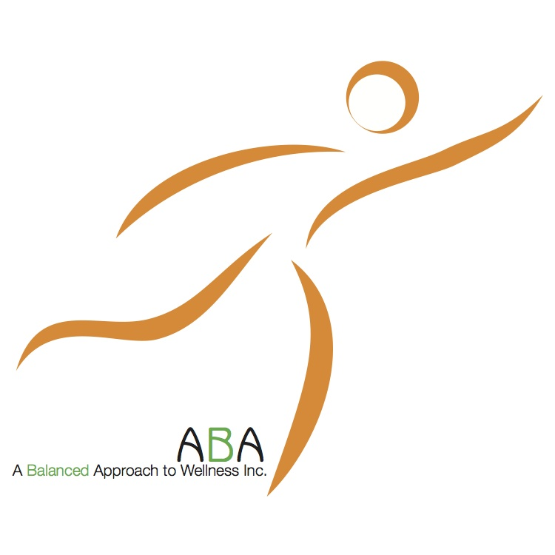
  
  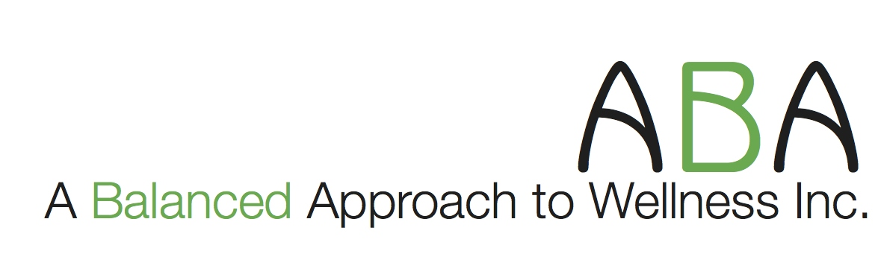
  A Greater Spectrum of Individualized
  Health and Happiness
  ► Physical Therapy
  ● In-home care
  ● Outpatient care
  ► Personal Training
  ► Massage Therapy
  ► Nutritional
  Consultation
  ► Community Resources
  ► Local Events
Table of Contents  My Services 1  Personal Training Consultations 1  Functional Movement Screens (FMS) 1  One–on-One Personal Training Sessions 1  My Services Continued 2  Personal Training/ Group Sessions 2  Personal Training Sessions for the Family 2  Education on Prevention / Decreased pain Responses 2  Massage Therapy 3  Nutritional Consultation 3  Price List 4  Price List Cont 5  Community and Discounts / Incentives 5  Discounts and resources available to all!!!  1. Find something in the community or an easily attainable resource that promotes activity, nutrition, financial stability, arts....to name a few. Present the idea to me and the steps you are taking to help yourself / family in the direction of improved wellness as it pertains to you individually and I will take $10.00 off of any one of the services offered through ABA Wellness.  2. Present a receipt of any additional activity attended or sport program involvement within a month of submission, and I will take an additional $10.00 off of any one purchase through ABA Wellness.  3. If you wish to publicize your talent or art work please notify me as I will provide a space in any location I provide services to advertise your hard work and if desired assist in your success to sell your art if that is a goal of yours. |  |  | Group Discounts for family and friends cont..  Training Sessions – 2 people - 4 week program  ﻿Including 1 month gym membership  ﻿2 x / week @ 60 min sessions ..................................................$544.00 / 4 weeks  ​﻿(8 sessions at $34.00 / session and $ 272.00 a month / person)  ​  2 x/week @ 90 min sessions ………………............................$784.00 / 4 weeks  (8 sessions @ $ 49.00 / session and $392.00 a month / person)  Group Training Sessions – 4 + people - 4 week program  2 x / week @ 60 min sessions ..................................................$800.00 / 4 weeks  ​﻿(8 sessions at $25.00 / person and $200 a month / person)  ​  2 x / week @ 90 min sessions ………………............................$992.00 / 4 weeks  (8 sessions @ $ 31.00 / session and $ 248 a month / person)    Reduced fees for Families available!
 |  |  | 5

Price List….  1 month of one-on-one Personal Training  Including 1 month gym membership  2 x / week @ 60 min sessions..................................................$336.00  ﻿( 8 sessions at $42.00/ session)  ﻿  2 x / week @ 90 min sessions..................................................$456.00  (8 sessions at 57.00 / session)  ﻿  1 session options  ​1 Session @ 60 min....................................................................$57.00  ﻿1 Session @ 90 min....................................................................$70.00  Group Discounts for family and friends  Partner / Couple Consultation (2 individuals) ……………………………………………………………...$60.00 / 60 min  Family Consultations (up to 2 adults and 2 children)  ………………………………………………………………$70.00 / 60 min​​  .……………………………………...additional adult $15.00  ……………………………………….additional child $10.00 |  |  | Personal Training  Personal Training Consultations  Functional Movement Screens (FMS)  One–on–One Personal Training
  Individual Training Program
  Initial Consultation​......................... $ 42.00 / 60 min
  ​
  ​Functional Movement Screen..............................$49.99 / 60 min
  The 60 min FES does include a discussion and explanation of activities and findings. Additional health and health history consult is as follows
  with consultation of 30 min...................................................$59.99​​
  with consultation of 60 min...................................................$69.99
   | - ﻿- Your Health History  - - Your previous work-out experience  - - Your personal goals  - ﻿- What your activities during the day require  - Work, Family and Recreation/Hobbies
    
   | - This is an additional piece of the puzzle when considering your baseline assessment prior to compiling a work out regime. This is one tool that has proven effective within the initial assessment process to guide in determination of your specific asymmetric patterns. What this indicates is your strengths and weaknesses in view of functional mobility.  - Functional mobility: Performance in all activities during the day regardless of nature and exertion.  - Goal: To achieve optimal performance without hindrance or risk of injury. Considering the mechanical structure of each individual in stance and in motion.
    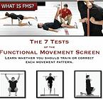
   | Individual guidance and supervision.  For all ages, activity and limitations.  We will make note each session of your progress, current goals and any particular concerns.  ﻿  er.  ﻿
    
4 |  |  | 1

Personal Training Continued  Personal Training / Group Sessions  Personal Training Sessions for the Family  Education on Prevention / Decreased Pain Responses |  |  | Massage Therapy  Massage Therapy Continued  Nutritional Consultations  Refer to My website www.abalncedapproach-wellness.com  Don’t Forget the Mission
  Do you have friend(s) that you would like to join in developing a group? | Take note of the discounts available.  - Your preference might be a team work approach. Together bring extra support and share common interests. Friends or family can bring a positive influence to keep training hard and can also learn from one another.
    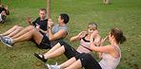
  ​Each workout session will introduce new and exciting workouts. We will build on previous sessions | - This provision accommodates to each family and there particular circumstances.  ﻿  - A fun and healthy way to spend time as a family in the midst of the "hustle and bustle" of our everyday agendas.  ﻿  - ﻿Up-building, quality time as a family.  I will accommodate to each member specifically regarding specific modifications and limitations as need be.
    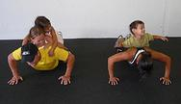
   | My experience in manual techniques and the results therein have been from my years of experience as a PTA. The favorable responses from my patients has lead me to utilize manual techniques with a
    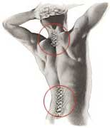
  - Therapy techniques with a multitude of restricted regions and for people of all ages. My credentials as a PTA support my approach. As a Licensed Massage Therapist, my added credentials and experience prove to assist in fulfilling the full spectrum of wellness that you deserve. This combination of care is individualized and carried out with a team of healthcare providers per your request and or preferences. | - To understand what Myofascial Release is and why it works, you have to understand a little about fascia. Fascia is a thin tissue that covers all the organs of the body. This tissue covers every muscle and every fiber within each muscle. All muscle stretching, then, is actually stretching of the fascia and the muscle, the myofascial unit.  - When muscle fibers are injured, the fibers and the fascia which surrounds it become short and tight. This uneven stress can be transmitted through the fascia to other parts of the body, causing pain and a variety of other symptoms in areas you often wouldn’t expect. Myofascial Release treats these symptoms by releasing the uneven tightness in injured fascia.
    
   | - Find Me on Facebook  - Continued resources available per request to best meet your Nutritional needs.
    
  Add a picture caption here. | Add your text here.
2 |  |  | 3

